October 2022
To API Engine Oil Licensing and Certification System Licensees:
Thank you for your participation in the API Engine Oil Licensing and Certification System (EOLCS). Your participation in the program and your commitment to manufacturing quality oils have helped to ensure that car and truck engines globally help to meet continuously more stringent fuel economy requirements and are protected against common causes of engine stress: heat, deposits, wear, oxidation, and corrosion.
Recently, API has been forced to waste resources in dealing with licensees who file their renewals late or not at all. Historically, the additional cost incurred in dealing with these late renewals has been absorbed by all licensees through their license fees, with the delays in licensing suffered by everyone, but API has chosen to address the issue in a more equitable manner. Effective April 1, 2023, API is implementing a late fee that will offset the resources incurred by API to process renewals after the annual expiration date of March 31. API will institute a late fee in the amount of $1,000.00 to companies who have not completed their renewal and paid all renewal fees by that date, in accordance with the legal agreement.
As a helpful reminder, the following steps outline the renewal process which opens on January 1 each year:
- Log on to your company account and click “Renew License” at the bottom of the Company info page.
- Electronically sign the EOLCS Legal Agreement and click “Next”.
- You will be directed to the Invoice Information page. Make any updates necessary to the Billing or Mailing addresses. Enter the Volume of Sales for your company – report all API licensed engine oil sold between January 1 and December 31 of last year.
- Once entered the volume amount cannot be changed. Corrections may only be addressed by contacting API. NOTE: You may be asked to provide an explanation for significant volume changes.
- Click “Generate Invoice”.
- On the Invoice and Payment Information page you must enter Payment Information to complete the payment process.
- We're happy to help you with any questions or concerns you may have. Please contact us directly at eolcs@api.org.

Again, we thank you for your participation in and dedication to the Engine Oil Licensing and Certification System. The program’s goal is to provide the highest level of quality and service to the worldwide lubricants industry, and we are committed to meeting this objective.
Sincerely,
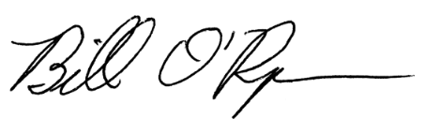
Bill O'Ryan
Sr Manager - EOLCS/DEF/MOM

